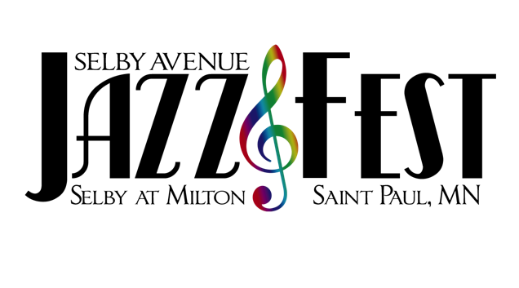

Presents:

2 0 2 3 V E N D O R A P P L I C A T I O N

Business Name: ____________________________________ Contact Name: _________________________________

Address: ________________________________________________________________________________________

City: ______________________________________ St: __________________ Zip: ___________________________

Phone: _____________________ E-mail: _______________________ Website: _______________________________

Please provide a brief description of your business (and menu if applicable; please include any attachments that will assist in telling your story).

_______________________________________________________________________________________________

_______________________________________________________________________________________________

 | Food Booth-$400 |  | Political Booth-$400
 | Artist Booth*-$175 |  | Nonprofit Organization-$175
 | Business Booth**-$250 |  | Major Corporation***-$600 +

IMPORTANT VENDOR DEFINITIONS: An artist booth* is defined as a space where the vendor is actively engaging in live demonstrations of their profession and talents—painting, creating jewelry, sketching, carving, etc. A business booth** is defined as a vendor who is retailing an item or service. Though they could be retailing an art-related item, a business booth vendor is not engaged in demonstrating the actual creation process. For example, a vendor whose booth features pre-made jewelry and is not engaged in actually making additional product on-site is defined as a business booth. Major corporations*** selecting to rent a booth space (vs. sponsoring the event) will be charged a minimum of $600.

Vendor booths are 10’ x 10’; food booths are 12’x 12’. Food vendors must include a copy of their city permit and have appropriate insurance. Vendors are responsible for taking all related trash to provided receptacles. Failure to keep a clean one’s area will seriously jeopardize participation in future Fests.

VENDOR POLICIES:
1. All vendors MUST provide pop-up style tent with weights to hold it down (no stakes; booths are on the street), tables & chairs.
2. Mail your check, payable to Selby Avenue JazzFest, and this completed form to: 2023 Selby Ave JazzFest c/o Golden Thyme Coffee Café, 934 Selby Ave, St. Paul, MN 55104. All vendor applications MUST be accompanied by cash or check payment. No exceptions.
3. As it has been for 21 years, JazzFest is a rain or shine event. No refunds will be given due to weather or acts of God. Please plan accordingly.

QUESTIONS:
FOOD VENDORS: Please contact Mychael Wright at 651.207.5945 or jazzfest.mw@gmail.com
ALL OTHER VENDOR INQUIRES: Please contact Stephanie Wright at 651.207.5945 or jazzfest.sw@gmail.com
COMPLETED APPLICATIONS ARE DUE BY 5:00 PM ON FRIDAY, AUGUST 11

___________________________________________________________________________________________________________________________________________________________________________________________________________________

For Internal Use: Ck # _____________ Cash: ______________ Rec’d: _____________ Deposited: ___________

